LAB ASSIGNMENT -03
QUESTION:01

Write a Java program to add two matrices of the same size.
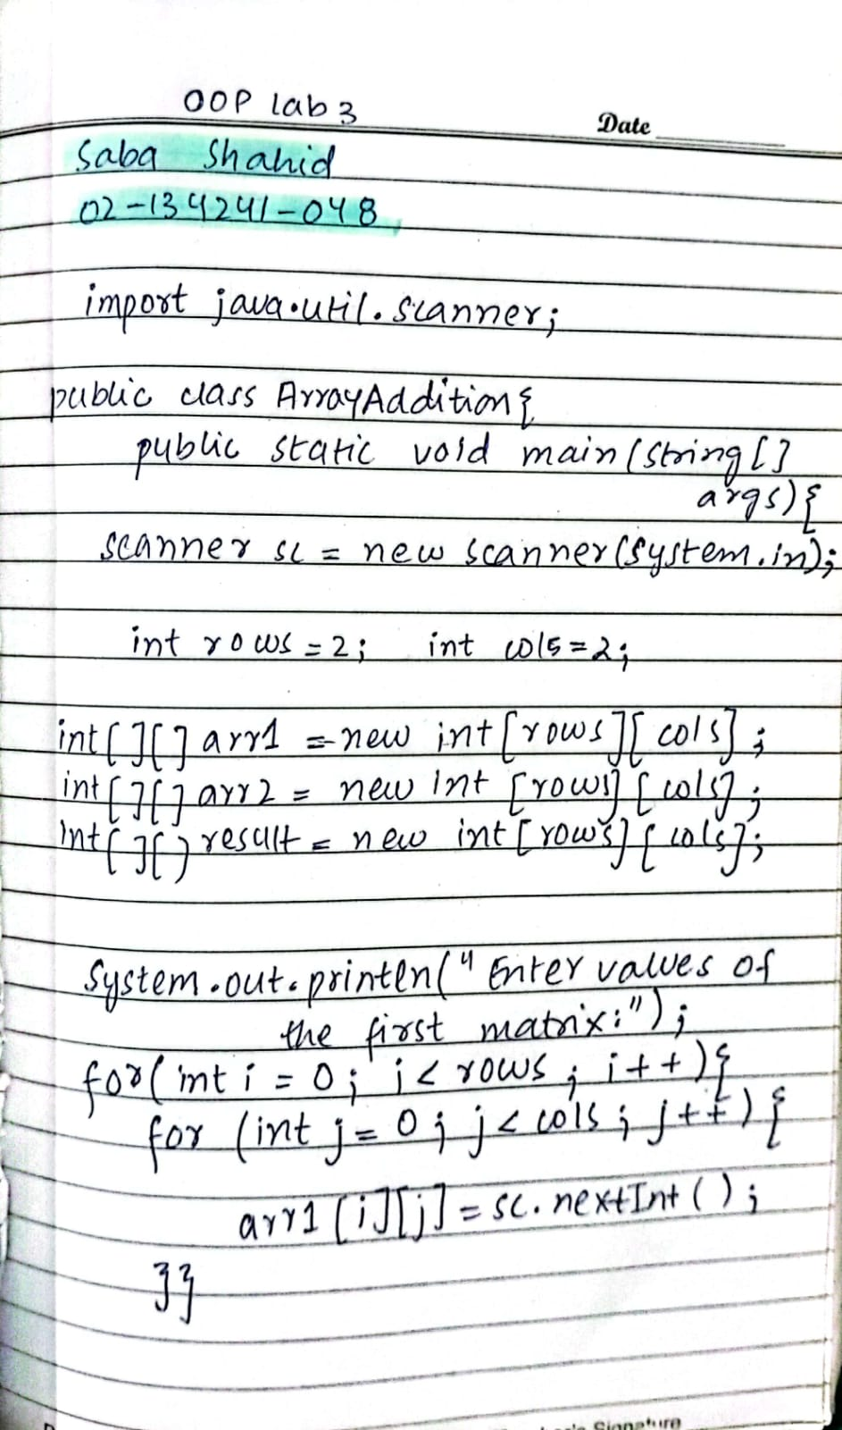
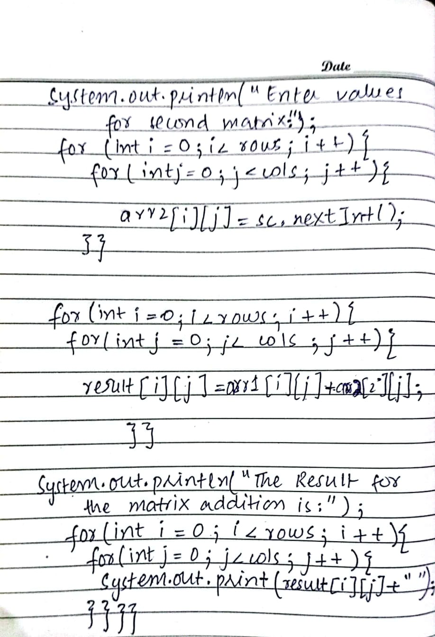

QUESTION NO:02
Consider you are a receptionist at hospital and whenever the patient comes you are to take his following info pNumber, pName, pAge, pEmail, pContact, pComplain and pBill then print the receipt for customer so method responsible for taking customer’s info is called as Take_Patient_data() and method responsible print receipt is called as Print_Receipt() Hint: Create global variable that is outside of the main method and use them in both methods for taking and printing customer’s details.
Take_Patient_Data(); Print_Receipt();

CODE
import java.util.Scanner;
public class HospitalReception {
// step 1 making Global variables to store patients data
static String pNumber;
static String pName;
static int pAge;
static String pEmail;
static int pContact;
static String pComplain;
static double pBill;
// Method for taking patient's data
public static void Take_Patient_data() {
Scanner scanner = new Scanner(System.in);
System.out.println("Enter Patient Number: ");
pNumber = scanner.nextLine();
System.out.println("Enter Patient Name: ");
pName = scanner.nextLine();
System.out.println("Enter Patient Age: ");
pAge = scanner.nextInt();
scanner.nextLine();
System.out.println("Enter Patient Contact: ");
pContact = scanner.nextInt();
scanner.nextLine();
System.out.println("Enter Patient Complain: ");
pComplain = scanner.nextLine();
System.out.println("Enter Patient Email: ");
pEmail = scanner.nextLine();
System.out.println("Enter Patient's Bill: ");
pBill = scanner.nextDouble();
System.out.println(" PATIENT REGISTERED :) ");
}
// Method to print the patient data on receipt
public static void Print_Receipt() {
System.out.println("-------------------------");
System.out.println("Patient Number: " + pNumber);
System.out.println("Patient Name: " + pName);
System.out.println("Patient Age: " + pAge);
System.out.println("Patient Email: " + pEmail);
System.out.println("Patient Contact: " + pContact);
System.out.println("Patient Complain: " + pComplain);
System.out.println("Patient Bill: " + pBill);
System.out.println("-----------------------");
}
// calling functions in Main method eeezii
public static void main(String[] args) {
Take_Patient_data();
Print_Receipt();
}
}

OUTPUT
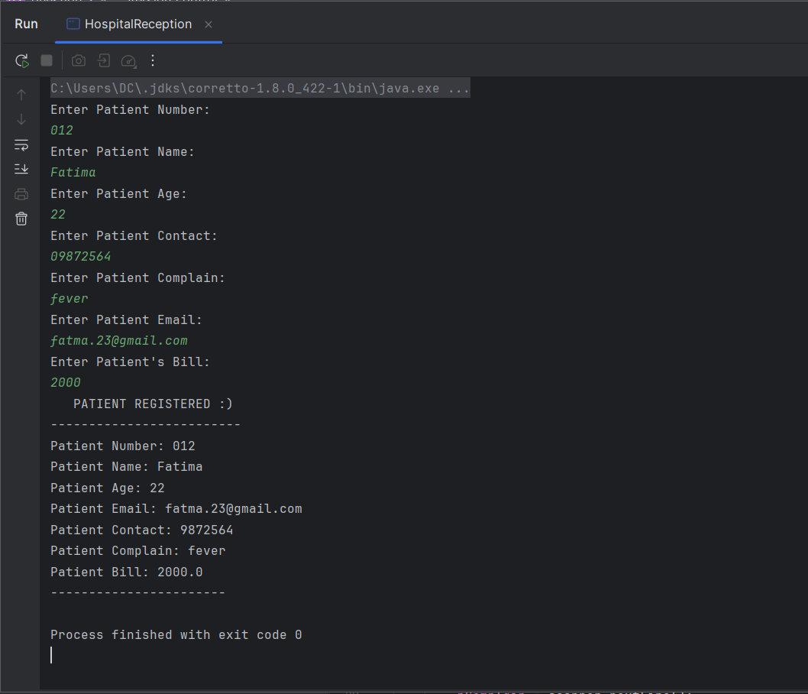

QUESTION NO:03
Write a recursive method to get sum of all number from 1 up to given number.
E.g. no. = 5 Result must be sum (1+2+3+4+5).
CODE
import java.util.Scanner;
public class SumOfNumbers {
// Method to calculate the sum
public static int calculateSum(int number) {
int sum = 0;
int i = 1;
// using loop for the recursive sum
do {
sum += i;
i++;
} while (i <= number);
return sum; // Return the calculated sum
}
//main class
public static void main(String[] args) {
Scanner sc = new Scanner(System.in);
System.out.println("Enter a number:");
int number = sc.nextInt();
// result mai function call karein ge
int result = calculateSum(number);
// printing result
System.out.println("Sum of numbers from 1 to " + number + " is: " + result);
}
}

OUTPUT
